To: Presidents of Locals in the PSAC Ontario Region

From: Craig Reynolds, Regional Executive Vice-President – Ontario
Leslie Searl, Chair, Health & Safety Committees, PSAC Ontario Council

cc: Ontario Regional Council, Component RVPs and NVPs, Regional Offices

Greetings,

We are pleased to announce the scheduling of the 2022 PSAC Ontario Health & Safety Conference and to extend this invitation to apply.

The conference is being held October 14 to 16, 2022, at the DoubleTree by Hilton, Toronto Downtown (108 Chestnut Street, Toronto, ON, M5G 1R3).

The theme of the conference will be:

BUT FIRST… MENTAL HEALTH

Conference Hours
The conference will commence on Friday, October 14, 2022, from 4:00 pm to 6:30 pm with a welcome plenary session and guest speakers. Saturday, October 15, 2022, will be a full day and the conference will close at approximately 2:00 pm on Sunday, October 16, 2022, to allow all participants to travel home.

Conference Logistics
Friday, October 14th |  | Travel for Out-of-Town Participants
 | 4:00 pm – 5:00 pm | Registration
 | 5:30 pm – 7:00 pm | Welcome Plenary Session / Guest Speakers
Saturday, October 15th | 7:30 am – 8:30 am | Registration
 | 9:00 am – 5:00 pm | Panel Presentation Workshops
Sunday, October 16th | 9:00 am – 12:00 pm | Regional Caucuses
 | 1:00 pm – 2:00 pm | Plenary Session and Closing
 | After 2:00 pm | Participants Travel Home

Selection of Participants
Participants will be selected to ensure diversity and representation from across the region, however, priority will be given to members from Joint Health and Safety Committees and/or Health and Safety Representatives.

Registration
Please complete the on-line registration form via the link or QR code below:
https://forms.office.com/r/iee9A3eaXG

Questions About Registering?
Please contact Kellie Loshak at the PSAC Kingston Regional Office:
E: loshakk@psac-afpc.com / T: 613-542-7322

COVID-19
We will follow all regional public health guidelines at the time of the conference. Participants will be socially distanced during all sessions.

Note: If you experience any symptoms, you will be required to isolate in your hotel room and contact Kellie Loshak immediately at 613-328-0226. Kellie will arrange for a Rapid
Test to be delivered to your room.

Travel
All participants at the conference will be funded according to the PSAC Travel Policy:
http://psacunion.ca/travel-policy

Participants are expected to travel by the most direct and economical means possible. Approval for travel and funding will be made on a case-by-case basis, dependent upon the participant’s location and in accordance with the PSAC Travel Policy.

Vehicles and Mileage (POMV)
Participants who choose to drive will be reimbursed according to the PSAC Travel Policy up to the most economic means of travel at the current rates at the time of the event. Travel by POMV requires prior approval. Approval will be granted on a case-by-case basis.

Loss of Salary (LOS)
Loss of salary will be compensated for any hours that a participant was regularly scheduled to work during the conference period. Most participants will travel during the
day on Friday, October 14, 2022, to arrive in time for the opening session at 4:00 pm. Participants who require additional LOS will require prior approval.

Members are encouraged to request Union
Leave with Pay to attend the conference.

Accommodation
Participants will stay at the DoubleTree by Hilton, Toronto Downtown, 108 Chestnut Street, Toronto, ON, M5G 1R3. All guest rooms will be arranged by the PSAC staff administering the event. Please note there will be a restriction on bringing in any outside food or drink to the meeting room.

Family Care
Please note that due to the uncertainties of the COVID pandemic on site family care will not be provided at this conference. Family Care costs will be reimbursed per the PSAC Family Care Policy: http://psacunion.ca/family-care-policy

Harassment, Scent and Smoke Free Environment
In accordance with PSAC policy, the 2022 PSAC Ontario Health and Safety Conference is a smoke-free, harassment free and scent free environment.

Greening the Conference - Paperless
The 2022 PSAC Ontario Health & Safety Conference will be paperless. Please bring a laptop to view necessary documents or let us know if you require a laptop for use during the conference. If you require paper documents, you may note this under “Special Requirements” on the registration form.

Applications must be submitted by end of day on July 15, 2022.

In Solidarity,

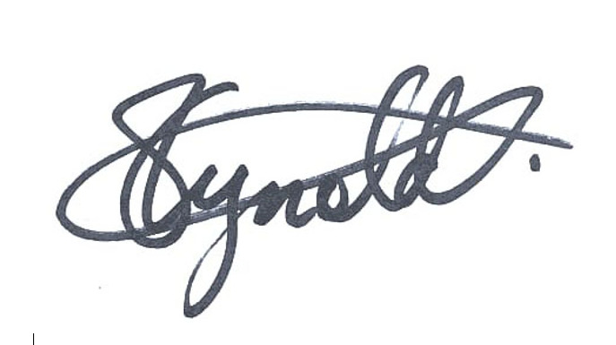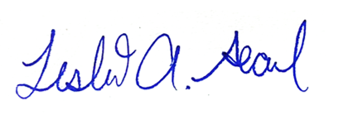
Craig Reynolds  PSAC Regional Executive  Vice-President, Ontario |  | Leslie Searl  Chair Health & Safety Committees, PSAC Ontario Council

